Review
Spiritual Types of Men
- Natural
  - 1 Cor 2:14, 1Jhn 4:5
- Carnal
  - 1 Cor 3:1, Rom 8:6-8
- Spiritual
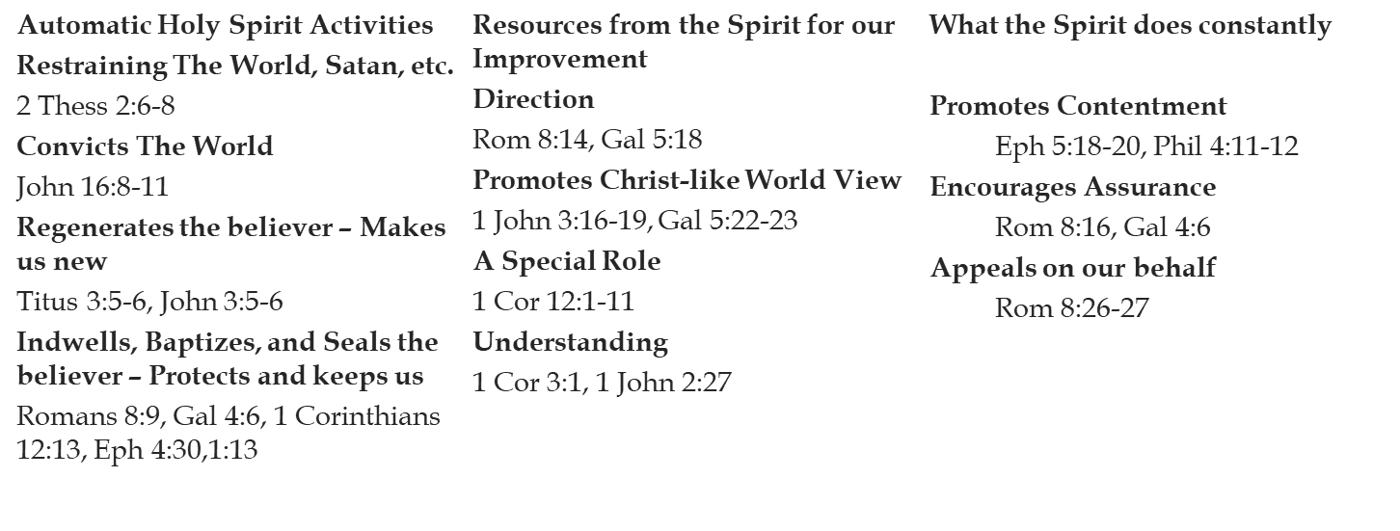
  - 1 Cor 2:15, Rom 8:1
Activities of the Spirit
Walk in the Spirit
- Do Not Fight the Holy Spirit
  - Ephesians 4:30-32
- Allow the Spirit to Work
  - Romans 6:12-13
- Walk in Faith
  - Galatians 3:11

Wrapping up being a Spiritual Man
What Does This Look Like?
- 1 John 2:24 & 4:16
  - John describes the life of a spiritual man as “abiding” with God and our fellow believers.
  - The basis of abiding is ____________________
  - Flows from desiring to Love God and ____________________fellow believers
  - Abiding – ____________________
- Hebrews 12:1-2
  - The author of Hebrews describes the life of a spiritual man as a race
  - The race is a lasting ____________________of Jesus’s example
  - Christ’s example demonstrates persevering towards the goal, despite ________________________________________
- 1 Corinthians 9:24-27
  - Paul describes the spiritual man as one who is competing in something like the Olympics
  - The life is full of preparation and is ____________________
  - The execution is controlled, focused, and in ____________________of good training
Wrapping it all up
- We are exhorted throughout scripture to desire to be ____________________, this means it isn’t automatic – build the desire for a _________________________!
- Endure, prepare, execute – plan for _______________________________________
- Abide, Train, Run, Fight – Long term goal not __________________________________

